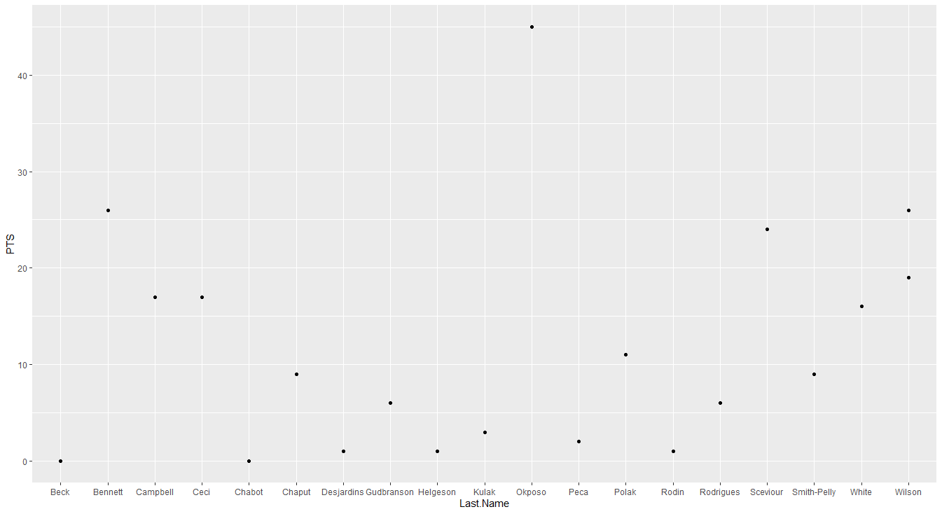

Graph Assignment - Brendan McWilliam

This plot shows the number of points that 20 random players in the NHL accrued over the 2014-2015 season. Their last name matches to a point on the graph with the number of points they have. The whole data set would not work because the last names of all 600+ players were too cluttered.